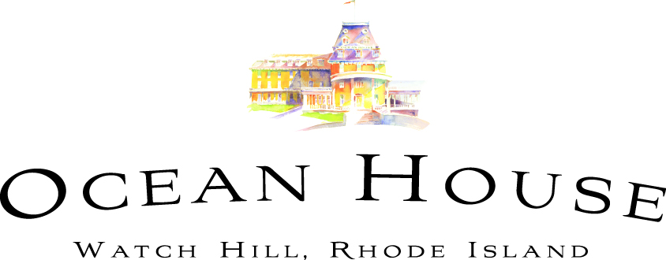

Special Event Information Sheet

Event: Mother’s Day Buffet in the Ballroom

Date: Sunday, May 12th, 2019

Time: Continuous seatings from 9AM to 3:30PM in Ballroom and Drawing Room

Location: Seaside Ballroom and Drawing Room – with Buffet located in Gallery Foyer

Price: $85.00++ per person; $45.00++ 4-12 years plus tax and gratuity; children 3 years and under are free, 20% will be added to all bills

Includes: Traditional Buffet, coffee, tea and soda; Valet Parking

Excludes: All Beverages Full Bar will be Available on a Cash Basis; tax and gratuity

Description: Enjoy a spectacular buffet in the ballroom featuring all of the traditional brunch favorites.

Buffet Menu

Salads
Roasted Ruby Beet Salad, Wild Roquette, Praline Pecans, Local Fresh Goat Cheese, Citrus
Cucumber Salad, Jicama, Pickled Sweet Onion, Toy Box Tomatoes, Lemon
Compressed Strawberry & Spinach Salad, Aged Feta, Sunflower Seeds, Balsamic

Anti-Pasto
Bread Display - artisan breads, Crackers, Rolls
Cheese Display – Manchego, Cambozola Black Label, Brie, Dried Fruits, Nuts
Dried Meats – Serrano, Capicola, Dry Salami, Favored Mustards, Pickled veg

Chilled Soups – Watermelon and Tomato Gazpachos

Raw Bar
Raw Bar Shrimp Cocktail and Local Oysters, Cocktail Sauce, Mignonette, Remoulade, Lemon
Smoked Salmon, Potato, Crème Fraiche, Chive, Greens

Breakfast Station
Breakfast Pastries – Croissants, Muffins, Breakfast Breads
Assorted Fruit and Berries – Pineapple, Melons, Mixed Berries
Vanilla Yogurt Parfait – Granola, Berries, Local Honey

Omelets and Eggs Station: Cooked to order with choice of toppings

Applewood Bacon, Chicken Sausage
Thyme Roasted Young Potatoes
Roasted Vegetable Frittata
Scrambled eggs with Chives
French Toast, Fruit Compote, Whipped Cream

Carving Station
Herb Roasted Beef Tenderloin, Red Wine Sauce, Brussel Sprouts
Garlic & Rosemary Pork, Charred Onion Mashed Potato, Citrus Chimichurri

Main Buffet
Maine Lobster & Spring Vegetable Risotto
Honey Glazed Salmon, Brussel Sprouts, Pistachio Gremolata
Johnna Crab Crepes, Spicy Aioli, Crispy Onion
Roasted Chicken, Orzo, Spinach, Tomato, Onion
Roasted Rainbow Carrots
Haricot Verts, Crispy Prosciutto, Parmesan

Children’s Buffet
Mixed Fruit Cup
Cinnamon French Toast Sticks, Maple Syrup
Small Pancakes, Maple Syrup
Cheese Pizza
Chicken Tenders, Tater Tots
Steamed Broccoli

Dessert Display
Tiramisu
Lemon-Raspberry Cupcakes
Assorted Macarons
Chocolate-Caramel Tarts
Strawberry Shortcake
Honey Financier
Vanilla Bean Cheesecake
Chocolate, PB & J Tart
Creamsicle Mousse
Lemon Panna Cotta

Reservations: By calling Destination Services, not available for online booking

Booking Streams: By Phone, Online, In Person

Open To: Everyone

Cancellation Fee: Cancellation fee of $85/$45 per person for any cancellation within 72 hours of arrival; take Credit
Card number at time of reservation to guarantee reservation.

Suggested Dress: Resort Casual; No Jeans

Entertainment: Pianist Michael Campbell

Seating: Reservations sheet is configured for tables up to 12 guests. For parties larger than 12 guests, please
take a telephone number, and number of guests and e-mail the Banquet Manager.

Parking: Valet Parking (included in the price)

Other Dining Options: A four course menu is available in COAST for Mother’s Day. After 6:30pm the Bistro menu will be available in the lounge.

